# Atlas Demonstration Toolbox

This document describes the example Atlas use cases provided in the Demonstration Toolbox. Atlas is a fully general software analysis and visualization platform. Users write Atlas queries to produce interesting graphs and solve specific use cases. The use cases described here are the tip of the iceberg of what Atlas can do, and are meant to provide a glimpse of what is possible.

Atlas Demonstration Toolbox 1

Prerequisites 1

EnSoft Atlas 1

Android SDK 1

Demonstration Toolbox 1

Code Comprehension Demo 2

Safe Synchronization Demo 5

API Compliance Demo 8

Resources 12

# Prerequisites

## EnSoft Atlas

The Atlas Demonstration Toolbox requires an Eclipse install with the EnSoft Atlas plugin. If you do not have a copy of Atlas, please visit EnSoft’s request page.

**Atlas Request:** <http://www.ensoftcorp.com/atlas_request/>

## Android SDK

The Atlas Demonstration Toolbox provides Android apps as analysis examples. For the best experience, please download the Android SDK and install the ADT plugin for your Eclipse install.

**Android SDK:** <http://developer.android.com/sdk/index.html#download>

**ADT Plugin:** <http://developer.android.com/sdk/installing/installing-adt.html>

## Demonstration Toolbox

To use the Demonstration Toolbox, you will need a copy of the toolbox project. Use the link below, download the project, and import it into your Eclipse workspace.

**Demonstration Toolbox:** <https://github.com/EnSoftCorp/Demonstration-Toolbox>

# Code Comprehension Demo

**Scripts:** src/com.ensoftcorp.atlas.java.demo.comprehension.ComprehensionUtils

**Example App:** app/connectbot

**Setup:**

1. Import ConnectBot, index with Atlas.
2. Open Atlas Smart View from the Demonstration-Toolbox (right click on Demonstration-Toolbox project and select Atlas->Open Atlas Smart View.

Software today is large and complex. In order to maintain or even understand a large code base, software engineers need effective comprehension tools to answer questions such as:

*What methods call method M?*

*Where does type T sit in the inheritance hierarchy?*

*What data may flow to variable V?*

Some “canned” tools exist for answering questions like this. Unfortunately, these tools tend to be hard-coded for a set of very specific use cases, and cannot be customized or used for other purposes. With Atlas, we can write customized scripts to answer these questions, without diminishing the flexibility or generality of the tool!

Let’s give this a try. Open the class org.connectbot.util.Encryptor, and select the encrypt method. Suppose we’re a developer and we just made a change to this method. Now we’d like to know the impact of our change by looking at a call graph of the method. Select the “Call” script from the Atlas Smart View.

The following graph is produced.

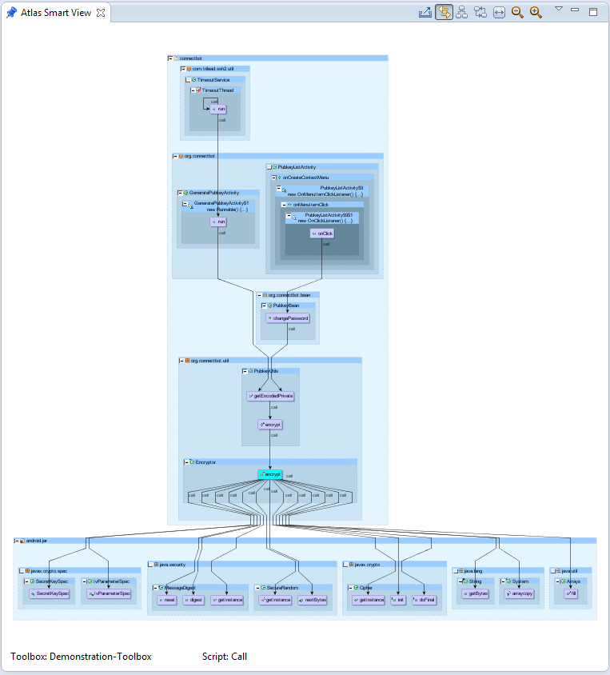

Notice that the encrypt method itself is highlighted in cyan. Now, suppose we made a specific change to the way encrypt uses its parameter, iterations. Perhaps we would like to see a data flow graph of where this data comes from and flows to. Select the “Dataflow” script from the Atlas Smart View and select the iterations parameter in the encrypt function.

The following graph is produced:

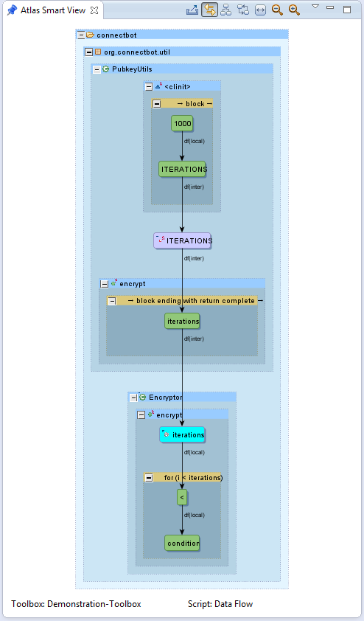

Again, the parameter itself is highlighted in cyan. Finally, suppose we want to see the type hierarchy for Encryptor to ensure that we’ve made our changes in the correct spot. Select the Encryptor class (either in the previous graph, or else in its source code), and select the “Type Hierarchy” script from the Atlas Smart View.

The following graph is produced:

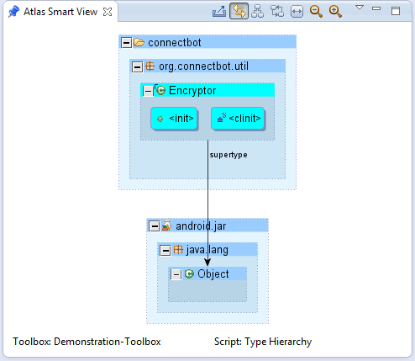

We see that Encryptor directly inherits from Object, and nothing extends it. Now that we have used Atlas to evaluate the potential impact of our changes, we are comfortable that all is well.

# Safe Synchronization Demo

**Scripts:** src/com.ensoftcorp.atlas.java.demo.synchronization.RaceCheck

**Example App:** app/Synchronization-Example

**Setup:**

1. Import Synchronization-Example, index with Atlas.
2. Open Atlas Smart View from the Demonstration-Toolbox (right click on Demonstration-Toolbox project and select Atlas->Open Atlas Smart View.
3. Open the classes in the example, ProducerConsumerSafe.java and ProducerConsumerUnsafe.java, for viewing.

In the previous example, we showed how Atlas can be used to perform fairly vanilla code comprehension tasks. Let’s do something a bit more customized. Suppose we’re the authors of a multithread application which employs the producer/consumer design pattern. We know that any shared data structures modified by multiple threads should be locked for exclusive access. Have we done this correctly in our application? We can write an Atlas script to check!

public void dangerous() {

sharedBuffer.add(someItem);

}

public void safe() {

synchronized(sharedBuffer){

sharedBuffer.add(someItem);

}

}

Consider RaceCheck.scala, inside which is a method called raceCheck. This method takes an expression representing some shared data structures whose access we should check. Then, it finds various control flow blocks from which reads and writes to that structure are made. For each of these accesses, raceCheck determines whether it is made under a synchronized block or not. Those accesses which happen under synchronized blocks are “safe” and are colored blue, while potentially dangerous accesses are colored red.

def raceCheck(sharedTokens:Q):DisplayItem = {

var decContext = edges(Edge.DECLARES)

var rwContext = edges(Edge.READ, Edge.WRITE)

rwContext = differenceEdges(rwContext,

rwContext.edgesTaggedWithAny(Edge.PER_METHOD))

var accessors = stepTo(rwContext, sharedTokens) union

stepFrom(rwContext, sharedTokens)

accessors = accessors difference declarations(methods("<init>")

union methods("<clinit>"))

var synchronizeBlocks =

universe.nodesTaggedWithAny(Node.SYNCHRONIZED)

var decBySynchronized = decContext.forwardStep(synchronizeBlocks)

accessors = accessors difference

(edges(Edge.CONTROL_FLOW).reverseStep(decBySynchronized)

difference decBySynchronized)

var goodAccesses = empty

var badAccesses = empty

var ge = 0

for(ge <- accessors.eval.nodes){

var geQ = toQ(toGraph(ge))

var revDec = decContext.reverse(geQ)

if((revDec intersection synchronizeBlocks).eval.nodes.size

> 0){

goodAccesses = goodAccesses union geQ

} else{

badAccesses = badAccesses union geQ

}

}

…

}

Let’s use the raceCheck Atlas script to check the thread safety of our shared buffer data structure.

We can contribute custom scripts to the Atlas Smart View. Here we have contributed the raceCheck script to the Smart View as “Safe Synchronization”.

Select the “Safe Synchronization” script from the Atlas Smart View and open ProducerConsumerUnsafe.java and click on the buffer field. The following graph is produced:

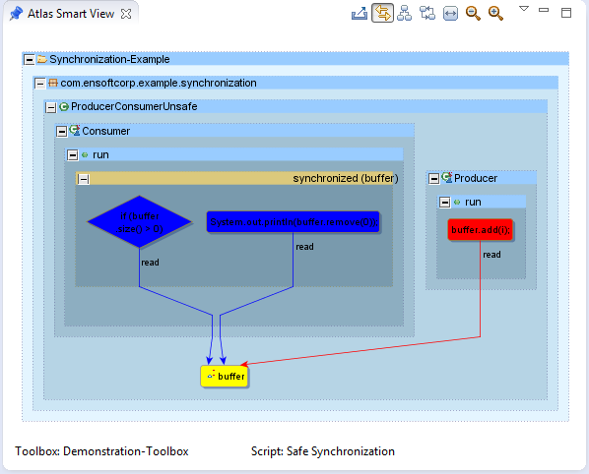

It looks like our script has detected an error! Click on the red control flow block to take us to the error location in the code. We see that someone has commented out the synchronized block in the Producer thread.

Open ProducerConsumerSafe.java which has this block re-added. Click on the buffer field again. Now, let’s see if our script shows that the problem is fixed.

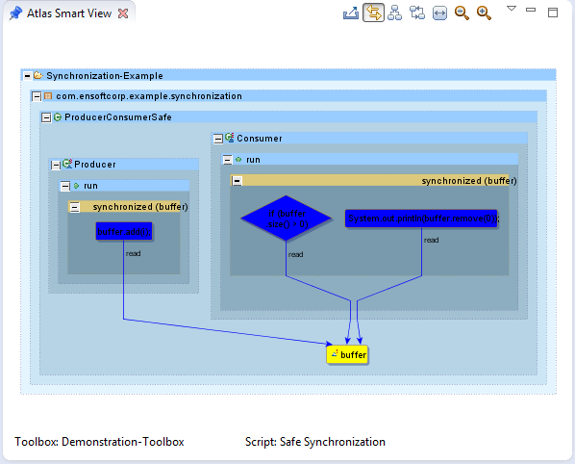

Looks good! Our script has confirmed our fix. Notice that this functionality was **not** provided by Atlas. We created a tool with this functionality by writing a custom script! Atlas allows us to add new features and tools on-the-fly, unlike other analysis tools. This means that we have the power to add more features, tweak existing functionality, remove functionality, etc. to our heart’s content! Other code comprehension tools do not offer customization like this.

# API Compliance Demo

**Scripts:** src/com.ensoftcorp.atlas.java.demo.apicompliance.APICompliance

**Example App:** app/Android-Audio-Capture-Example

**Setup:**

1. Import Android-Audio-Capture-Example, index with Atlas.
2. Open Atlas Smart View from the Demonstration-Toolbox (right click on Demonstration-Toolbox project and select Atlas->Open Atlas Smart View.
3. Open the only class in the example, MainActivity, for viewing.

Here we will show another highly-customized analysis example using Atlas. Suppose we are the authors of a brilliant new Android app which records audio. Android provides a set of APIs for audio capture (<http://developer.android.com/guide/topics/media/audio-capture.html>). A sequence of nine method calls, setting up various aspects of the recording, is required. Suppose we wish to know if our Android app uses these APIs correctly. We can write an Atlas script to check!

“

Audio capture from the device is a bit more complicated than audio and video playback, but still fairly simple:

1. Create a new instance of android.media.MediaRecorder.

2. Set the audio source using MediaRecorder.setAudioSource(). You will probably want to use MediaRecorder.AudioSource.MIC.

3. Set output file format using MediaRecorder.setOutputFormat().

4. Set output file name using MediaRecorder.setOutputFile().

5. Set the audio encoder using MediaRecorder.setAudioEncoder().

6. Call MediaRecorder.prepare() on the MediaRecorder instance.

7. To start audio capture, call MediaRecorder.start().

8. To stop audio capture, call MediaRecorder.stop().

9. When you are done with the MediaRecorder instance, call MediaRecorder.release() on it. Calling MediaRecorder.release() is always recommended to free the resource immediately.

“

Take a look at APICompliance.scala, which contains a custom method called androidAudioCapture. This method selects the nine relevant API methods, then defines an expected ordering for calls. Next, it builds a control flow graph of our application, and identifies where the API call events occur. Finally, each call event is sorted into a “good” or “bad” group based upon whether all prerequisite calls were made prior to making this call. In the resulting graph, correct API calls are shown in blue, while incorrect calls are shown in red.

def androidAudioCapture():DisplayItem = {

var callContext = edges(Edge.CALL)

var cfContext = edges(Edge.CONTROL_FLOW)

var mediaRecorder =

methodSelect("android.media","MediaRecorder","MediaRecorder")

var setAudioSource =

methodSelect("android.media","MediaRecorder","setAudioSource")

var setOutputFormat =

methodSelect("android.media","MediaRecorder","setOutputFormat")

var setOutputFile =

methodSelect("android.media","MediaRecorder","setOutputFile")

var setAudioEncoder =

methodSelect("android.media","MediaRecorder","setAudioEncoder")

var prepare = methodSelect("android.media","MediaRecorder","prepare")

var start = methodSelect("android.media","MediaRecorder","start")

var stop = methodSelect("android.media","MediaRecorder","stop")

var release = methodSelect("android.media","MediaRecorder","release")

var apis = mediaRecorder.union(setAudioSource, setOutputFormat,

setOutputFile, setAudioEncoder, prepare, start, stop, release)

val requisiteOrder = Array(mediaRecorder, setAudioSource,

setOutputFormat, setOutputFile, setAudioEncoder, prepare, start,

stop, release)

var cfGraph =

inducedGraph(app.nodesTaggedWithAny(Node.CONTROL_FLOW), cfContext)

var apiCalls = callContext.forwardStep(cfGraph) intersection

callContext.reverseStep(apis)

cfGraph = cfGraph difference (cfGraph difference

cfGraph.between(apiCalls, apiCalls))

var cfEnhanced = cfGraph union apiCalls

val (goodCalls, badCalls) = precedenceCheck(requisiteOrder, cfEnhanced)

…

}

Let’s run this on our Android app to see how we’ve done. Here we have contributed the APICompliance script to the Smart View as “Media Recorder API Compliance”.

Select the “Media Recorder API Compliance” script from the Atlas Smart View and open the MainActivity.java class and click on the initWrong method. The following graph is produced:

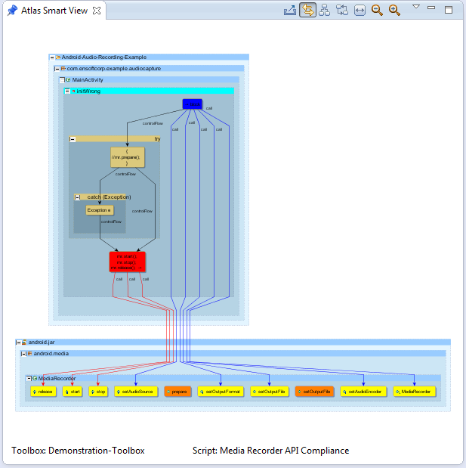

Our Atlas script detected problems with our app. Click on the red control flow block from which the errant calls are made. We see that we have forgotten to call prepare prior to starting the recording.

This is corrected in the initCorrect method. Now click on the initCorrect method. The following graph is produced:

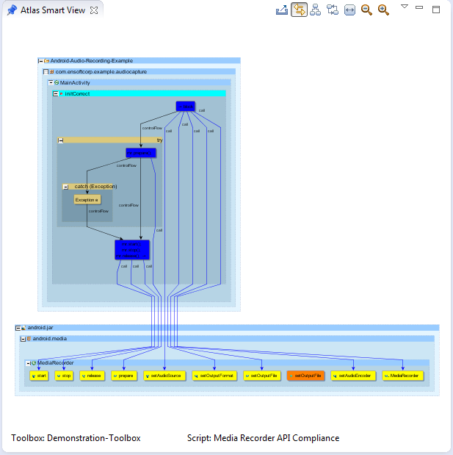

Looks good! Our Atlas script has confirmed our fix, and all API calls are now made in the correct order. As with the previous demonstrations, notice that this functionality was **not** provided by Atlas. We created a tool with this functionality by writing a custom script! Atlas allows us to add new features and tools on-the-fly, unlike other analysis tools.

# Resources

**Android SDK:** <http://developer.android.com/sdk/index.html#download>

**ADT Plugin:** <http://developer.android.com/sdk/installing/installing-adt.html>

**Atlas Product Page:** <http://www.ensoftcorp.com/atlas/>

**Atlas Request:** <http://www.ensoftcorp.com/atlas_request/>

**Demonstration Toolbox:** <https://github.com/EnSoftCorp/Demonstration-Toolbox>

**Email EnSoft:** [contactus@ensoftcorp.com](mailto:contactus@ensoftcorp.com)